Directions: The goal of the following problems is to help challenge and deepen your understanding of the current topic. Don’t assume that you will know how to answer each and every question. You will work with at least two other students in the class to try and find solutions and write arguments for each of the following questions. Be sure that you question your classmates’ reasoning. If you don’t understand how they are getting something you should ASK THEM TO EXPLAIN! Being able to defend your reasoning is important and so you are actually helping them by asking them to explain.

Challenge Questions

- Calculate each of the following derivatives.

- Compute the second derivative for the function .

EXTENSIONS
- Show how you can find the derivatives of the following functions without the use of the Chain Rule.

Without the chain rule:

With the chain rule:
Note that .
Therefore, .

- .

Without the chain rule:
Note that .
Therefore,

With the chain rule:

Without the chain rule:
Note that .
Therefore, .

With the chain rule:
- Attempt to re-derive the derivative for .

If then . This implies that .
Therefore, .

So we see that .
We have shown .

- Compute each of the following derivatives.

- Let . Find values of m and b that make f differentiable everywhere.

We know that in order for a function to be differentiable at it must be the case that exists, that is it must be true that the limit exists.

Since we want to show that is differentiable at we must show that exists.

We see that .

We then check the limit from both sides.

The second limit can’t be finished yet, but we note that since the limit from the left equals 4 we also need the limit from the right to equal 4 in order for the limit to exist and thus have be differentiable everywhere.

If we let and , then and thus which implies that is differentiable at .

So, is differentiable everywhere.

- In algebra we learn about the concepts of even and odd functions. A function is called odd if for all values of x. A function is called even if for all values of x.

- Sketch the graph of a possible odd function. Sketch the graph of a possible even function. Hint: It may be helpful to start by plotting a few points on each function and then thinking about what the definitions tell you about other points that must also be on these functions.
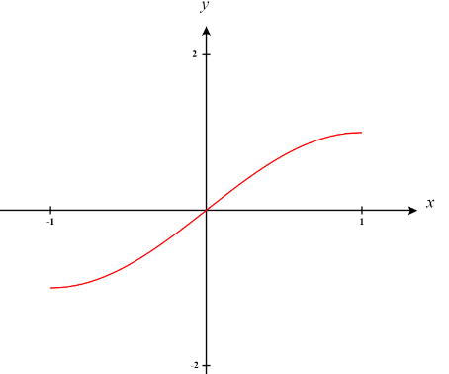
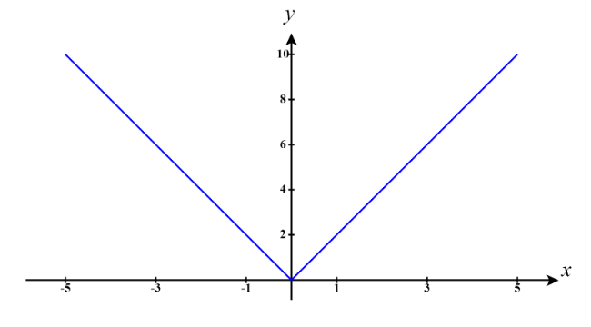

Even Function Odd Function

- Show that is even. Let n represent any integer value. Is even for all values of n, odd for all values of n, or does it depend on n? Justify your answer. What about ?

If then we can see that . This implies that is even.

If then we can rewrite this function as . Notice that regardless of the value of n. This implies that is even.

If then we can rewrite this function as . Notice that regardless of the value of n. This implies that is odd.

- Show that the derivative of an arbitrary odd function is even and that the derivative of an arbitrary even function is odd.

Suppose is an odd function, we know that for all x. We take the derivative of both sides and find that .
This means that is an even function.

Suppose is an even function, we know that for all x. We take the derivative of both sides and find that .
This means that is an odd function.

- Show that if is odd, then . Is the same true for even functions?

If is odd then we know that . If then this means that . Note that cannot be positive or negative else is not true. Therefore, must equal 0.

If is even then we know that . If then this means that . Note that can equal anything and this statement must still be true. Therefore, need not equal 0 if is an even function.

- Give an example of a function that is both odd and even. Prove that your example is the only function that is both odd and even (Hint: Consider what would have to be true if another function which does not equal 0 for all values of x was both even and odd.).

Consider the function . We see that because and because . This confirms that is both even and odd.

Suppose that is another function is both even and odd but for all x. If and then this mean that which implies that for all x. This creates a contradiction and so it must be the case that the only function which can be both even and odd is

